**Justice in Europe and the Mediterranean**

30/01/2019

**Collaboration, communication and continuation: EUROMED Forum of Prosecutors General meets at Eurojust**

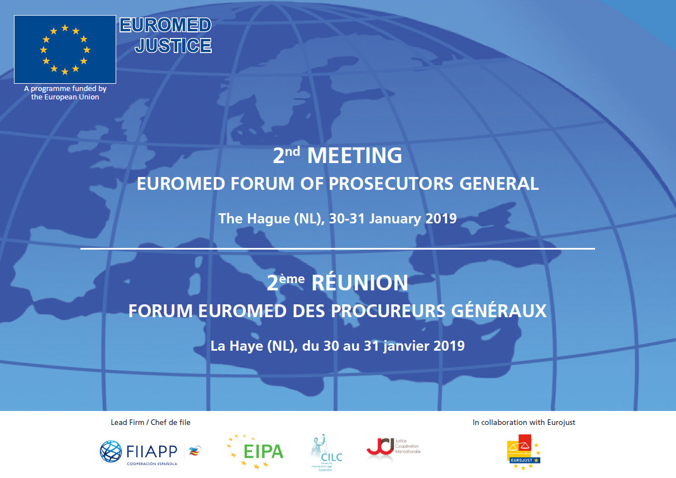

**Eurojust is pleased to host the second meeting of the EuroMed Forum of Prosecutors General at its premises in The Hague on 30 and 31 January.**

The goal of the EuroMed Forum is to enhance international judicial cooperation between EU Member States and Southern partner countries (Algeria, Egypt, Israel, Jordan, Lebanon, , Morocco, Palestinian Authority and Tunisia). Since 2016, Eurojust has been involved in a total of 39 cases with these countries, and has developed a network of nine contact points, who facilitate cooperation on joint cases.

This year’s meeting will bring together the Prosecutors General from seven of these countries and from 9 EU Member States (Belgium, Cyprus, France, Greece, Italy, Malta, the Netherlands, Portugal and Spain), as well as representatives from EU agencies and international organisations (Eurojust, the EJN, the Consultative Forum, UN CTED, UNODC, IAP, DG NEAR and DG JUST, EuroMed Police, EuroMed Justice, FIIAPP and the NADAL Network).